**MODIFICATIONS**

In the initial report, I focused on explaining the SHAP (SHapley Additive exPlanations) values for a single instance, which provided a limited view of the model's behavior. Upon further consideration and analysis, I recognized the importance of understanding the SHAP values across a broader spectrum of data points. To address this, I extended my analysis to include the SHAP values for the first ten instances in the dataset.

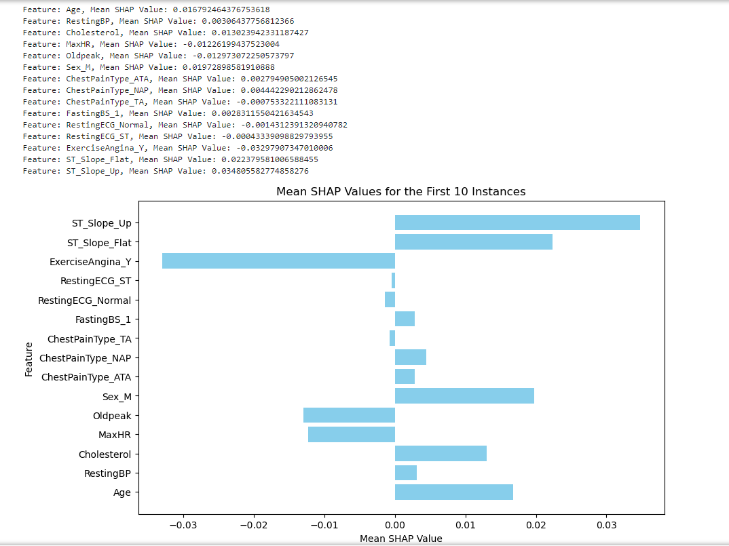

Attributes in the SHAP values that are not aligning with the real-life medical scenario or common knowledge about heart disease risk factors:

* ChestPainType_TA (Negative SHAP): In the first set, ChestPainType_TA has a negative SHAP value, implying a lower contribution to the likelihood of heart disease. However, typically, any type of chest pain (including typical angina) is considered a significant symptom of potential heart issues. The negative SHAP value for ChestPainType_TA contradicts this expectation.
* RestingECG_ST (Negative SHAP): The negative SHAP value for RestingECG_ST suggests that having an ECG result showing ST-T wave abnormalities is contributing less to the likelihood of heart disease. However, ST-T wave abnormalities in ECG readings are often indicative of cardiac issues and are closely monitored by medical professionals.